Crop Disease Detection in Agriculture
Poorna Sakamuri

Abstract:

Crops are super important for making food all over the world. Agriculture plays a big role in making money for a country by growing crops. But sometimes, they get diseases because of things like bad weather or pests, which can make it hard for farmers to grow enough food. Spotting these diseases by just looking at the plants takes a long time and can be tricky because some diseases look like others. Spotting crop diseases is super important for keeping agriculture strong. If we can quickly and accurately find these diseases, it helps keep farms healthy and saves a lot of money and resources. Every year, farmers lose a ton of money because of different crop diseases. So, we can use computer programs called Machine Learning (ML) and Deep Learning (DL) to help. Deep learning can step in here and help farmers catch diseases early on, especially in leaves, so they can prevent crops from failing. These programs can quickly find plant diseases early on, which helps stop them from spreading and ruining crops. In this project all we do is to help the farmers with computer programming and make it work for finding plant diseases. The trials in the project show that using these computer programs makes it easier and more accurate to spot sick plants. This project makes use of advanced technology like Machine Learning and Deep Learning for finding plant diseases which would be helpful for people who study plant diseases and for farmers because it shows what works well and what needs to be improved. By understanding these challenges and limits, researchers and farmers can work together to make farming better and more efficient.

Key Words:
Agriculture, crop disease detection, machine learning, deep learning, farmers, classification, image processing.

Introduction:

Crops are crucial to living organisms because they create oxygen. These plants contribute to the ecological balance of the ecosystem. Plant parts, including flowers, leaves, fruits, grains, and stems, are consumed, and utilized by both animals and humans. Their extracts have also been used in mustard oil, medicine, biofuels, and food. Crops, just like people, are grouped based on characteristics like how tall or big they are, what color they are, and what shape they have. But, like people getting diseases, crops can also get diseases. This can harm how they normally grow. These sicknesses can affect different parts of the crops, like their roots, flowers, fruits, or leaves. Plants pathologists classify and identify diseases based on leaf characteristics such as shape, size, color, and texture. Due to the huge number of crops and complexity, there are also many numbers of plant diseases.

Using ML technology can really help farmers with identifying and managing crop diseases. To increase the farm productivity and to save money and to stimulate the crop treatments using the environmentally crops the technology helps to provide tools which are essential. Precision agriculture is a modern farming strategy that uses high-tech tools to improve crop growth. The overall goal is to grow a lot of healthy food while simultaneously taking care of the environment. The goal is to employ technology to increase farming efficiency and effectiveness. This allows farmers to produce more food while minimizing environmental impact. So, precision agriculture is all about using smart tools to grow food in a better, healthier way. To do this, it's important to use technology that can find diseases in plants early. These diseases can make farmers lose a lot of money and make the crops not as good. By using technology to find diseases early, farmers can fix them quickly. This helps keep the crops healthy and makes farming better for the environment.

Achieving this involves reducing the adverse impacts of pesticides and other plant protection agents.

As a result, analyzing leaf image symptoms will provide insight into numerous plant illnesses. Various diseases, like blight affecting crops such as potatoes, tomatoes, and peppers, can lead to substantial financial losses for farmers annually. Blight manifests in two types: early blight caused by fungi and late blight by specific bacteria. Early detection and treatment of diseases help farmers save both money and time. With the global population projected to reach more than trillions within the upcoming years, food production must increase to meet the growing demand.

Diseases that affect crops are particularly concerning, given that they are the most grown around the world. Nonetheless, infections in peppers and tomatoes are a serious worry. Keeping the everlasting slogan "prevention is better than cure" in mind. Agricultural experts are trying with deep learning to prevent crop diseases. Machine learning techniques have shown promise in extracting data from real-time image processing because of huge advances in computation.

Several studies have implemented or proposed machine learning methods for detecting or classifying plant diseases. Most of these studies use a plant/leaf image as an input to determine whether a disease occurs. These studies tackle the problem as a classification, either binary (healthy or diseased plant/leaf) or multi-class (targeting several diseases). Classical machine learning approaches, such as Random Forest (RF) and Deep Learning (DL), have been used for this purpose.

Data:

PlantVillage is a dataset on crop diseases produced by Pennsylvania State University. PlantVillage has 54,305 RGB photos representing 38 plant disease types. It comprises photos of fourteen different plants. Each plant contains at least two classes of photos displaying healthy and sick leaves with dimensions of 256 x 256. Figure 1 shows sample photos from the collection. Since the release of this dataset, various plant disease identification investigations have been conducted.

Color Images: In the PlantVillage collection have three color channels: red, green, and blue.

Grayscale Images: Grayscale photos in the PlantVillage dataset include only one channel that represents the intensity of light at each pixel.

Segmented Images: The PlantVillage collection contains segmented photos that have been processed to extract plant leaves from the background and isolate sections of interest, such as sick areas or symptoms.

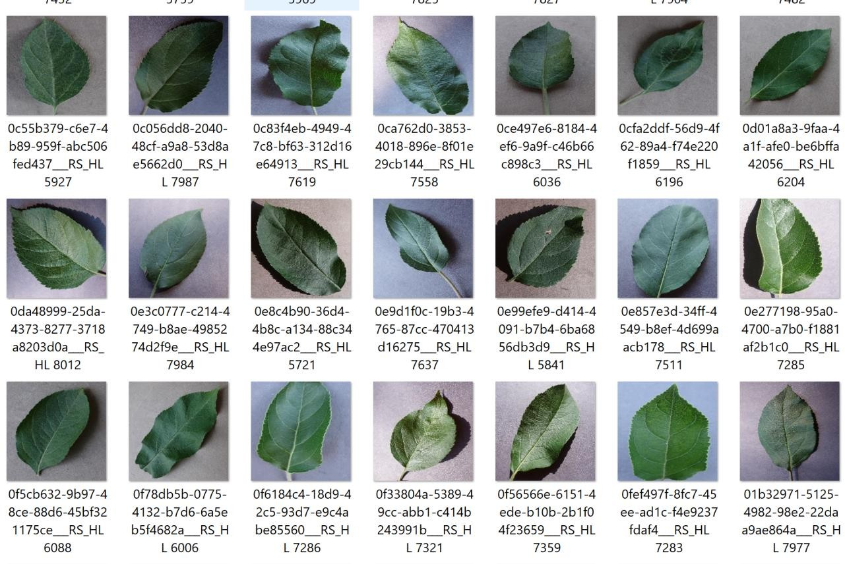

Fig. 1: Sample Image

These images were taken under regulated lighting and color settings, which might not necessarily equate to a snapshot taken outdoors. To solve this, the team is currently increasing their image library to over 150,000 to increase the system's ability to detect diseases. Furthermore, they plan to increase the volume of data utilized by the network to ensure precise diagnoses.

Species of the dataset contain photos of 14 different plant species. Image characteristics of the dataset are often high-quality, with a single background and little impediments. However, there are variations in it. Images depend on the dimensions which may be different sizes. Lighting

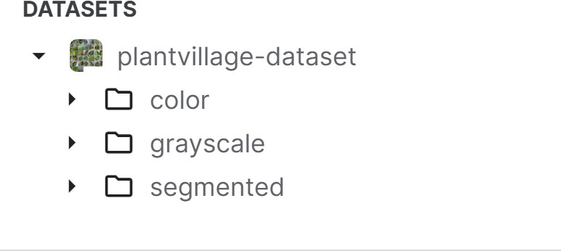
conditions and natural color variations may be present. Disease patterns might differ between leaves if it is observed based on the location of sick areas. Noise, blurring, and light intensity may be present to some amount.

Fig.2: Dataset

1

Preprocessing of Data:

Data preparation is a critical step in getting the Plant Village Dataset ready for usage in machine learning models.

Resizing:

Standardize image dimensions to a constant size (such as 224x224 pixels) that is appropriate for your model's input layer. This ensures that each image is treated consistently.

Normalization is a technique which includes pixel values within a particular range (often 0–1). This allows the model to converge faster during training and avoids specific hues from dominating others.

Data Augmentation:

Data augmentation which creates artificial changes of existing photos to boost dataset size and model resilience. Techniques include Random cropping which takes tiny bits of the original image to capture different parts of the leaf. Random flipping (horizontal and vertical) which makes mirror versions to account for differences in how leaves are captured.

Train-test Split:

The train-test split is an important step in machine learning model construction. It entails splitting the dataset into two subsets: the training and testing sets. The training set is used to train the model, which involves learning the patterns and correlations between input data and target labels. The testing set evaluates the trained model's performance on previously unknown data. By evaluating the model's performance on the testing set, we can predict how well it will generalize to new, previously unknown data.

Label Encoding:

Machine learning algorithms often use numerical data. Therefore, categorical labels, such as disease names in the case of plant disease categorization, must be encoded into numerical representation. Label encoding is the process of assigning a unique numeric value to each label.

For example, if we have three types of diseases (e.g., "Healthy," "Blight," and "Rust"), we can give them integer labels like 0, 1, and 2, respectively.

Data Balancing:

Imbalanced datasets result from having less samples in certain classes compared to others. This can skew the model's learning process, resulting in skewed predictions for the majority class. Data balancing strategies seek to correct this imbalance by either boosting the representation of minority classes (oversampling) or decreasing the number of majority classes.

Performing these preprocessing processes efficiently prepares the Plant Village Dataset for use in training machine learning models for plant disease detection and classification. These processes help ensure that the data is clean, consistent, and appropriate for training robust and accurate models.

Methodology:

Image color is a fundamental and distinguishing element for plant image representation that has been utilized in image retrieval. This is since the color is invariant with translation, scale, and rotation. The color feature extraction includes color space, similarity measurements, and color quantization. There are numerous color descriptors, including color histograms.

Color Features for Plant Disease Detection:
Image color is a fundamental and distinguishing element for plant image representation that has been utilized in image retrieval. This is because the color does not change with translation, scaling, or rotation. Color space, similarity measures, and color quantization are all part of the color feature extraction process. Color histograms are one of many color descriptions.

Shape and Texture-Based Diseases:
Plant detection of the texture feature is a visual pattern with homogeneity features that do not result in the appearance of only one color. Texture characteristics include homogeneity, coarseness, contrast, and density. The gray-level co-occurrence matrix is one example of a texture characteristic. We can localize the leaf region by exploiting the color attributes of the leaf photos, followed by a model-based country expansion. The characteristics were retrieved using a fisher vector with varying orders of Gaussian distribution differentiations. We can utilize SVM classifiers. The performance of this technique was assessed using PlantVillage databases for potato, common pepper, and tomato leaf.

Deep learning theory:

Traditional manual image classification and recognition methods extract an image's underlying qualities using handcrafted features. However, these methods have limitations in terms of extracting information regarding an image's deep and complicated properties. This is because the manual extraction technique is heavily reliant on the competence of the person performing the analysis and is prone to errors and inconsistencies.

Convolutional neural network:
CNN learns by training the network with tagged photos of healthy and diseased plants. This paper proposes a framework for identifying plants as normal or aberrant based on leaf data. The system incorporates a variety of Inception designs, and the ultimate choice is reached using a bagging-based approach. The model generates probabilities for whether the leaf is diseased or healthy. CNNs' architecture, which includes up-sampling, down-sampling, and learnable layers, makes them ideal for detecting leaf diseases.

Model Training and Evaluation:

To analyze the model, we follow the procedures below:

- In an ideal dataset, 80% of the images are used for training and 20% for testing.

- Validation data is used to ensure correctness by executing the prediction function and extracting features precisely.
- Images are obtained to confirm detection if validation yields satisfactory findings.
- Finally, features are gathered to evaluate whether the leaves are diseased.

Performance Evaluation:
In this step, I determine the best model based on the results of extensive tests. I measured accuracy, precision, recall, f1score, training accuracy, training loss, validation accuracy,

and validation loss. This will aid in the development of a smart web application guided by deep learning principles.

I conducted a comparative performance study of the various models investigated for each of the four datasets from the PlantVillage platform, namely Apple, Corn, Grape, and Tomato. In general, we can see that all models perform better on the Grape dataset, but worse on the Tomato dataset. On the Grape dataset, I discovered that most models perform quite well, with very high F1-Score and Accuracy levels. This could imply that the photos in this dataset are easier to classify since they are generally sharper and have a better representation of the various classifications. The models' performance on the Tomato dataset is often the weakest when compared to the other datasets.
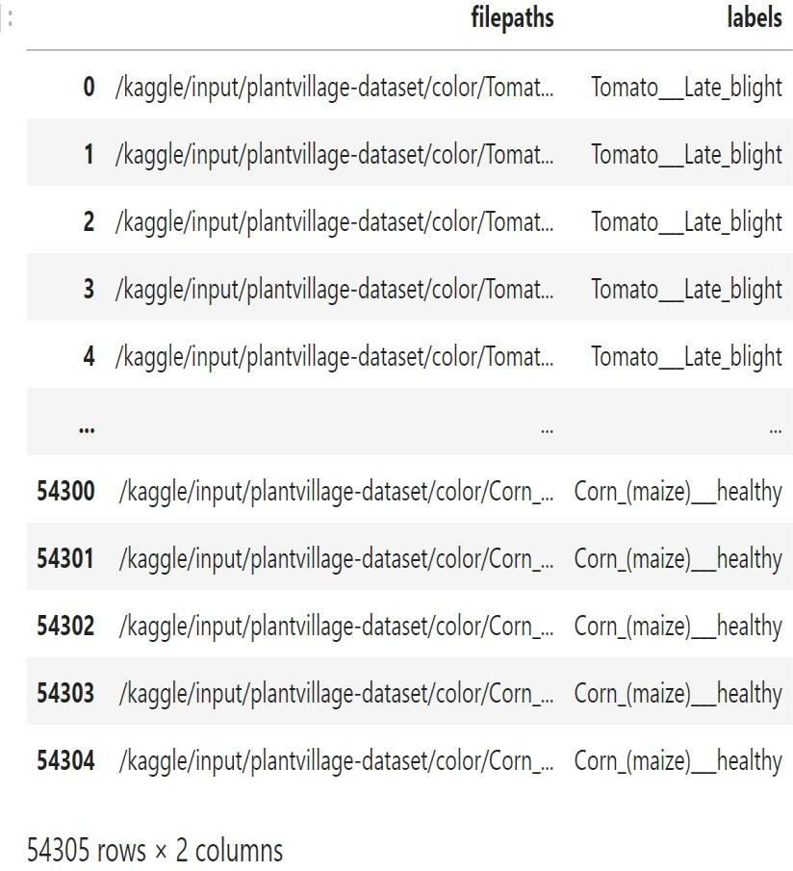

Fig. 3: Evaluation

Results and Insights:

With the dataset based on the color, grayscale, and segmentation I have mostly identified the diseases which cannot be visible to the naked eyes. Below shows some of the results of the project. Fig 4 shows the status of the leaf like healthy, Early blight and so on. Likewise, Fig.5 shows the status of the unhealthy leaf.
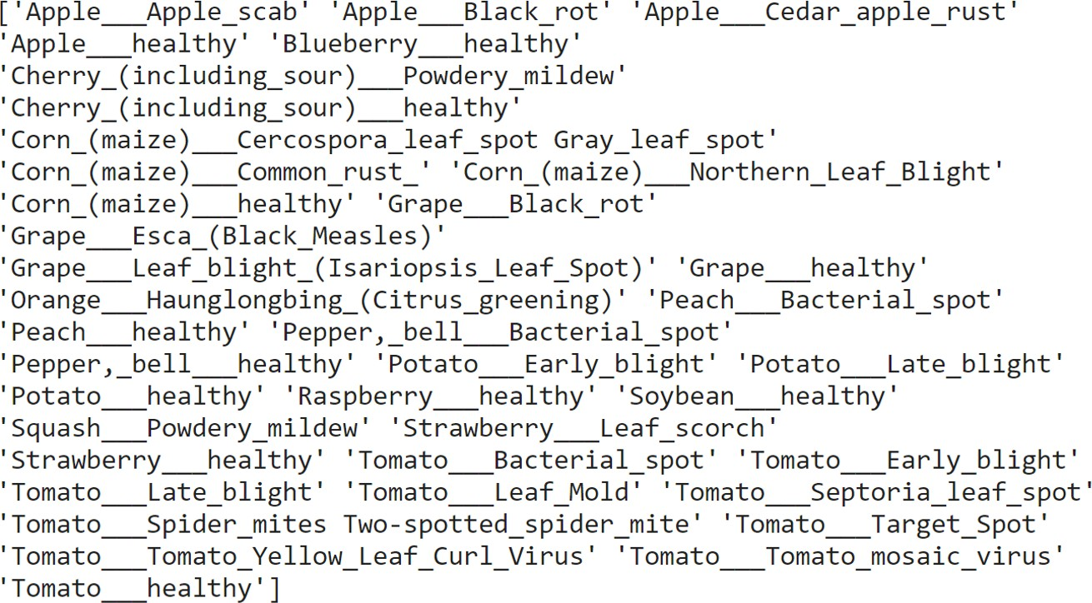

Fig.4: Status of leaf.

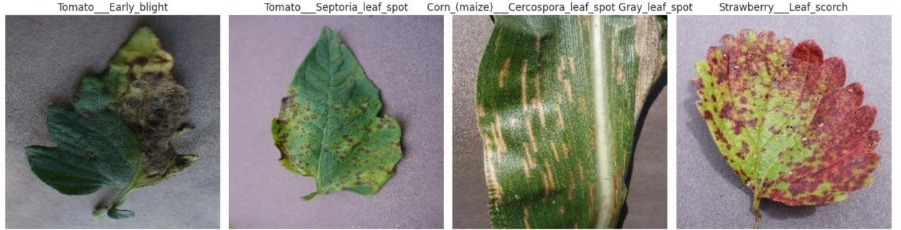

Fig.5: Diseases leaf

Challenges:

Our review of ML and DL algorithms for crop disease detection and classification, as well as a computational study of crop disease classification algorithms on a widely used dataset, revealed several challenges in practical crop disease detection applications.

Small leaf and early-stage illness recognition: Most current datasets include photos of huge leaves. Annotating datasets for early disease diagnosis and tiny leaf recognition is required.

The project focuses on disease detection by classification, either binary or multi-class. To accurately identify the illness kind and affected regions in a picture, it's important to focus on object detection rather than just classification.

Future Work:

In the future, I intend to investigate more techniques for categorization and object detection on larger datasets to determine whether the results are consistent across datasets. I also wish to increase the accuracy rate by creating a new hybrid deep-learning architecture that employs an attention-based mechanism, as well as plant leaf disease area identification or the development of a localization approach to detect diseased areas in the leaf.

Conclusion:

Crop and plant infection detection and control have substantially improved thanks to deep learning and machine learning technology. Advances in image recognition have enabled the identification of complex diseases and pests. To improve the model's resilience and generalizability, photos from different plant growth stages, seasons, and geographies should be collected. Early detection of plant diseases and pests is critical for avoiding and managing their spread and growth, hence combining meteorological and crop health data, such as temperature and humidity, is required for accurate diagnosis and prediction. A complete overview of current advances in the use of ML and DL approaches for plant disease identification, as well as offered solutions to solve the obstacles and limits involved with their deployment. By exploring the benefits, drawbacks of various methods, and offering valuable insights for researchers and industry professionals, this study contributes to the advancement of crop disease detection and prevention.

I used the provided improved accuracy model in the development to correctly detect crop disease. The DL technique application offers a smart agriculture system for disease detection. As a result, the proposed strategy outperformed previous crop disease investigations in terms of symptom severity estimation. This study advances crop disease diagnosis and prevention by investigating the benefits and downsides of various methodologies, as well as providing vital information for researchers and industry professionals.

